Robotics and Automation Class

Class project

1. Project definition

Author: Jesse kibicho

Date: 29.06.2023

Version: V 2.0

Topic: Using DHT sensor to check temperature and humidity of the environment of a robot

Objectives: The objectives of this IoT and Robotics project is to utilize a DHT sensor to accurately measure and monitor the temperature and humidity levels in the environment surrounding a robot. By integrating the sensor with the robot’s system, we aim to develop a robust solution

That enables real time data collection, analysis, and appropriate adjustments to optimize the robot’s performance

1. Project Design

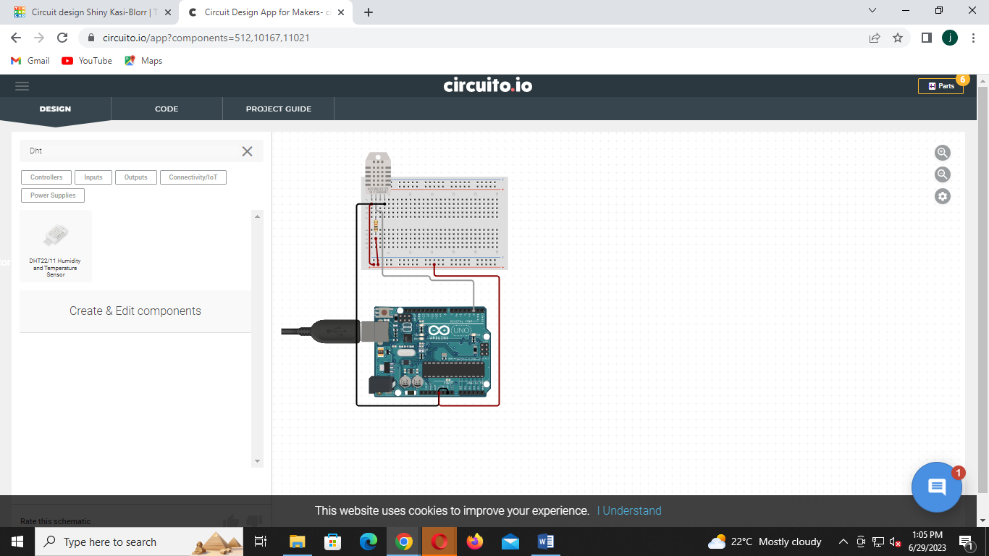

1. Connect the components
2. Program the microcontroller
3. Observe and report.

